Threat management and cybersecurity Resources

Key contributors:

Devon Brown

Daniel Garza

Candan Martin

April/15/2022

**Executive Summary(Candan&Daniel)**

The purpose of this project is to test the efficiency of detecting vulnerabilities using OpenVAS, Nessus, and Metasploit. We used 3 different operating systems Metasploitable, Fedora, and CentOS to test the efficiency of our vulnerability assessment tools. We used Metasploitable for its numerable vulnerabilities as our baseline least secure system. We used Fedora because it is used to host servers so we wanted to see how secure the system would be. We used CentOS because it is widely used by scientists so we wanted to compare its security to Fedora and Metasploitable. Candan will be using Nessus, Devon will be using OpenVAS, and Daniel will be using Metasploit.

We focused on Metasploitable because …

**These are the results that we got:**

**OpenVAS: (Devon)**

Intro: …

Experimental Procedure:

It consists of (X#) steps

Step 1.

…

-Image display of the report at the end

**Nessus: (Candan)**

Intro:

Candan used the Nessus vulnerability assessment tool to scan Metasploitable’s IP address and identify vulnerabilities in Metasploitable’s operating system. After scan, Nessus provided insight on the vulnerabilities found and Candan generated it’s general report

Experimental Procedure:

* It consists of 11 steps

Step 1.

Use ifconfig command in Metasploitable to identify IP address for metasplotable. Fig 1.

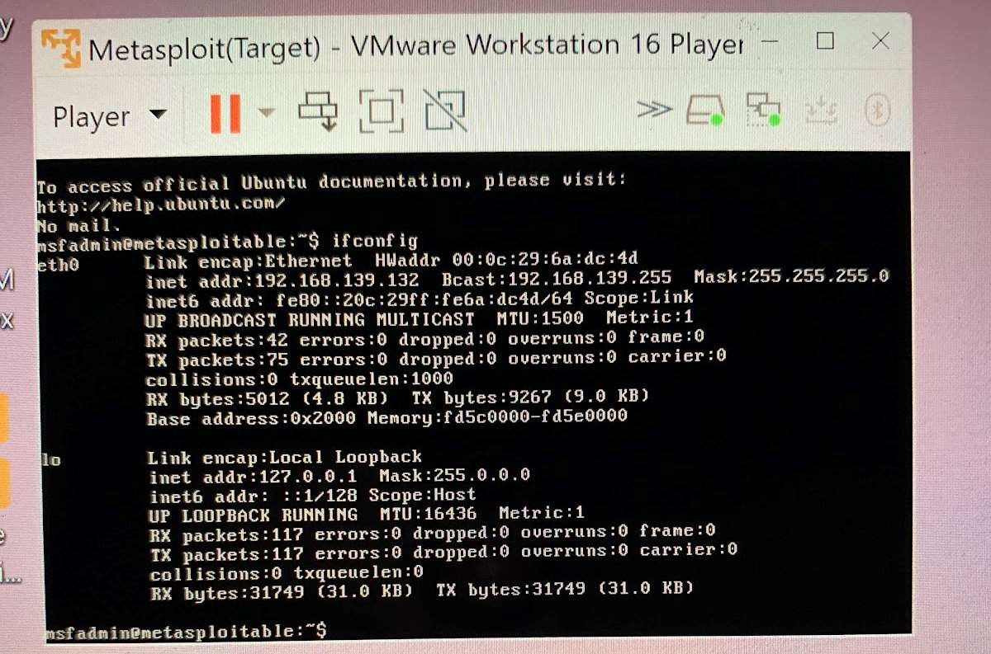

Fig 1. Metasploitable ip address is displayed

Step 2:

Open Kali Linux terminal and use command “ping “ to check for a connection from metasploitable our target machine. Fig 2.

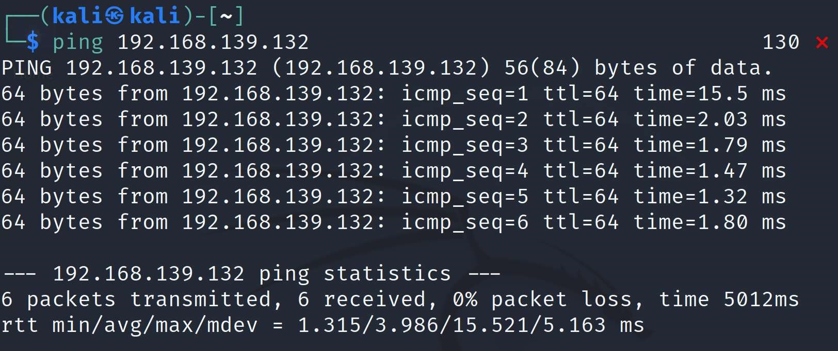

Fig 2.

Step 3.

Open the Nessus application in the Kali Linux VM.

Step 4.

Perform a scan with Nessus on the target VM. Provide screenshots and explain thoroughly each step.

Step 5.

Selected Basic Network Scan. Fig 3.

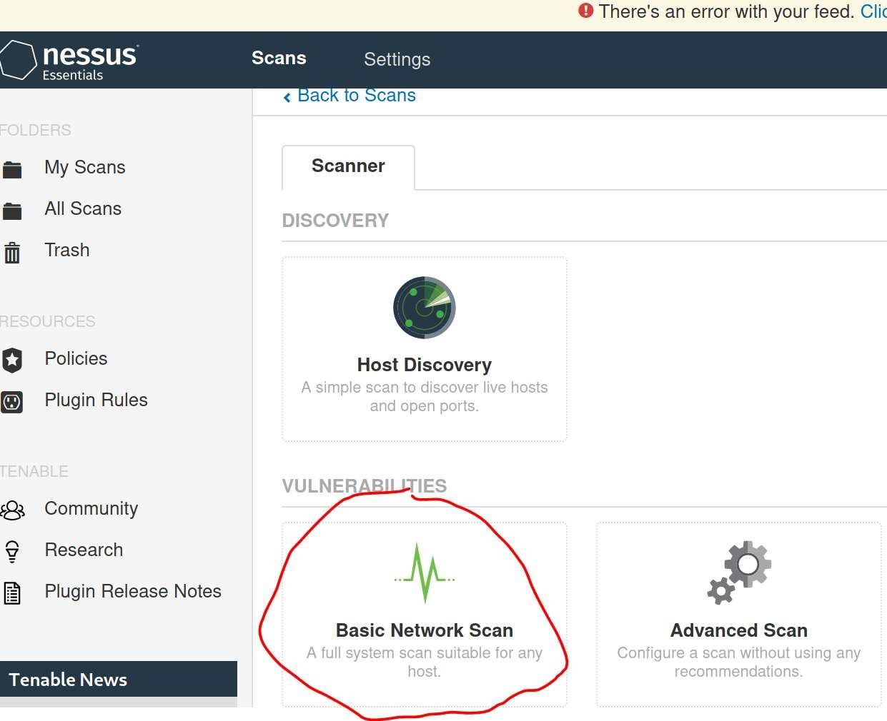

Fig 3.

Step 6.

Name the target OS. Make a description of target. Input target IP address into “Targets”. Save the scan. Fig 4.

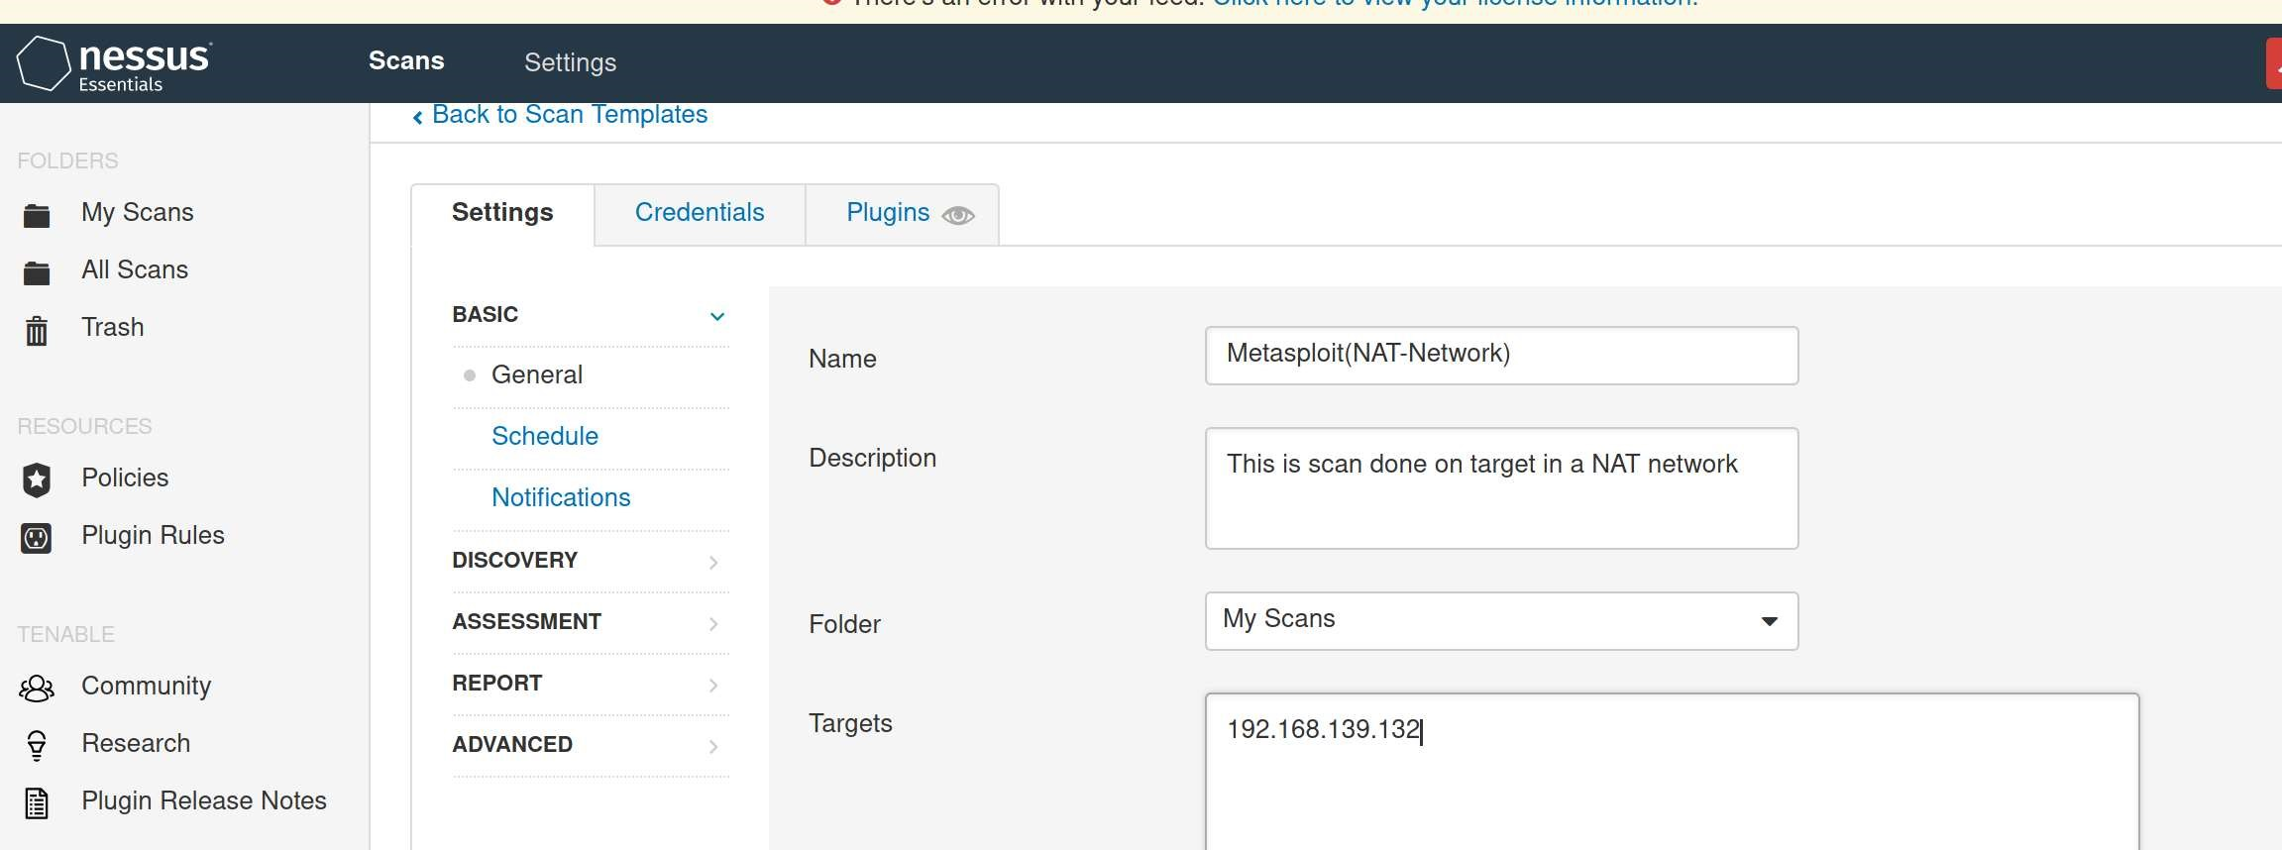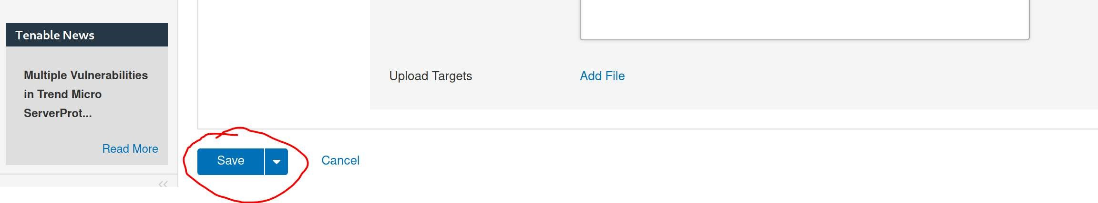

Fig 4.

Step 7.

Find scan that was created and select the play button to launch scan. This will tell Nessus to start the scan on the target OS(Metasploitable). Fig 5.

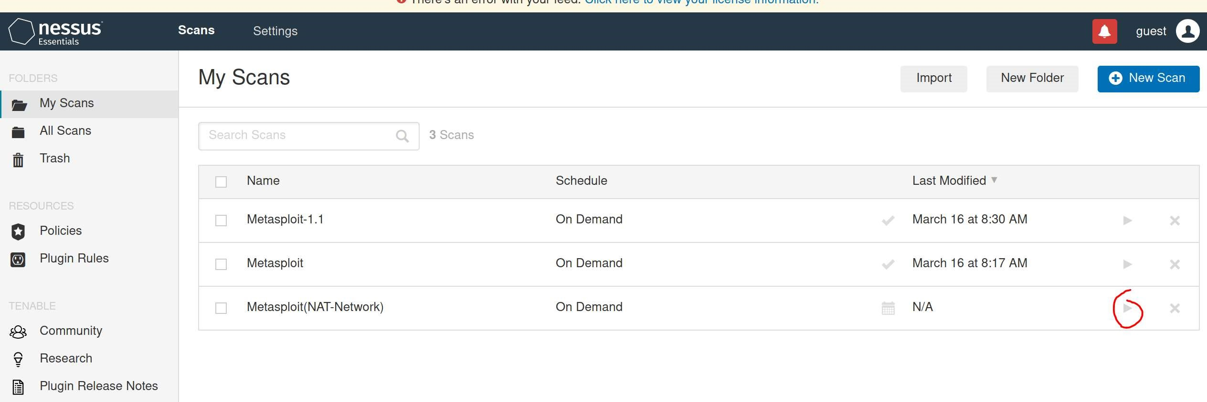

Fig 5.

Step 8.

Wait for the scan to complete. Fig 6.

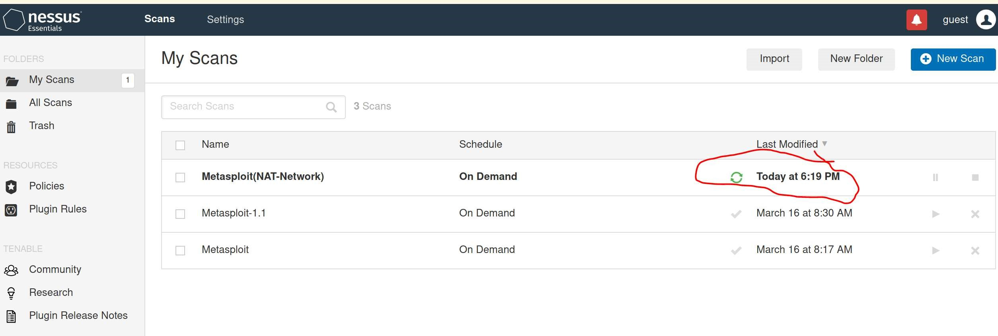

Fig 6.

Step 9.

Click on the Metasploit(NAT-Network) file created to view the scan

Step 10.

Select the vulnerabilities tab to view vulnerabilities found. Fig 7.

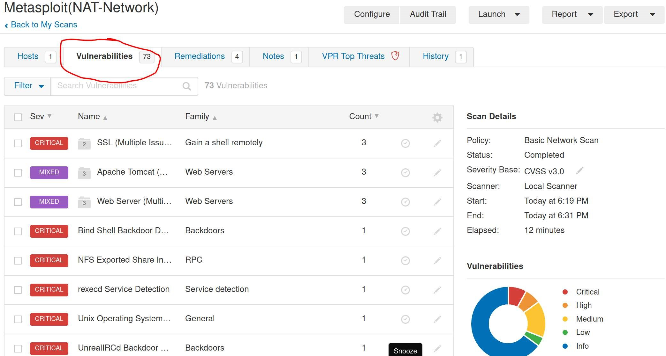

Fig 7.

Step 11.

Download the generated report from Nessus. Select Report→PDF and then generate with the default Executive summary selected. Fig 8.

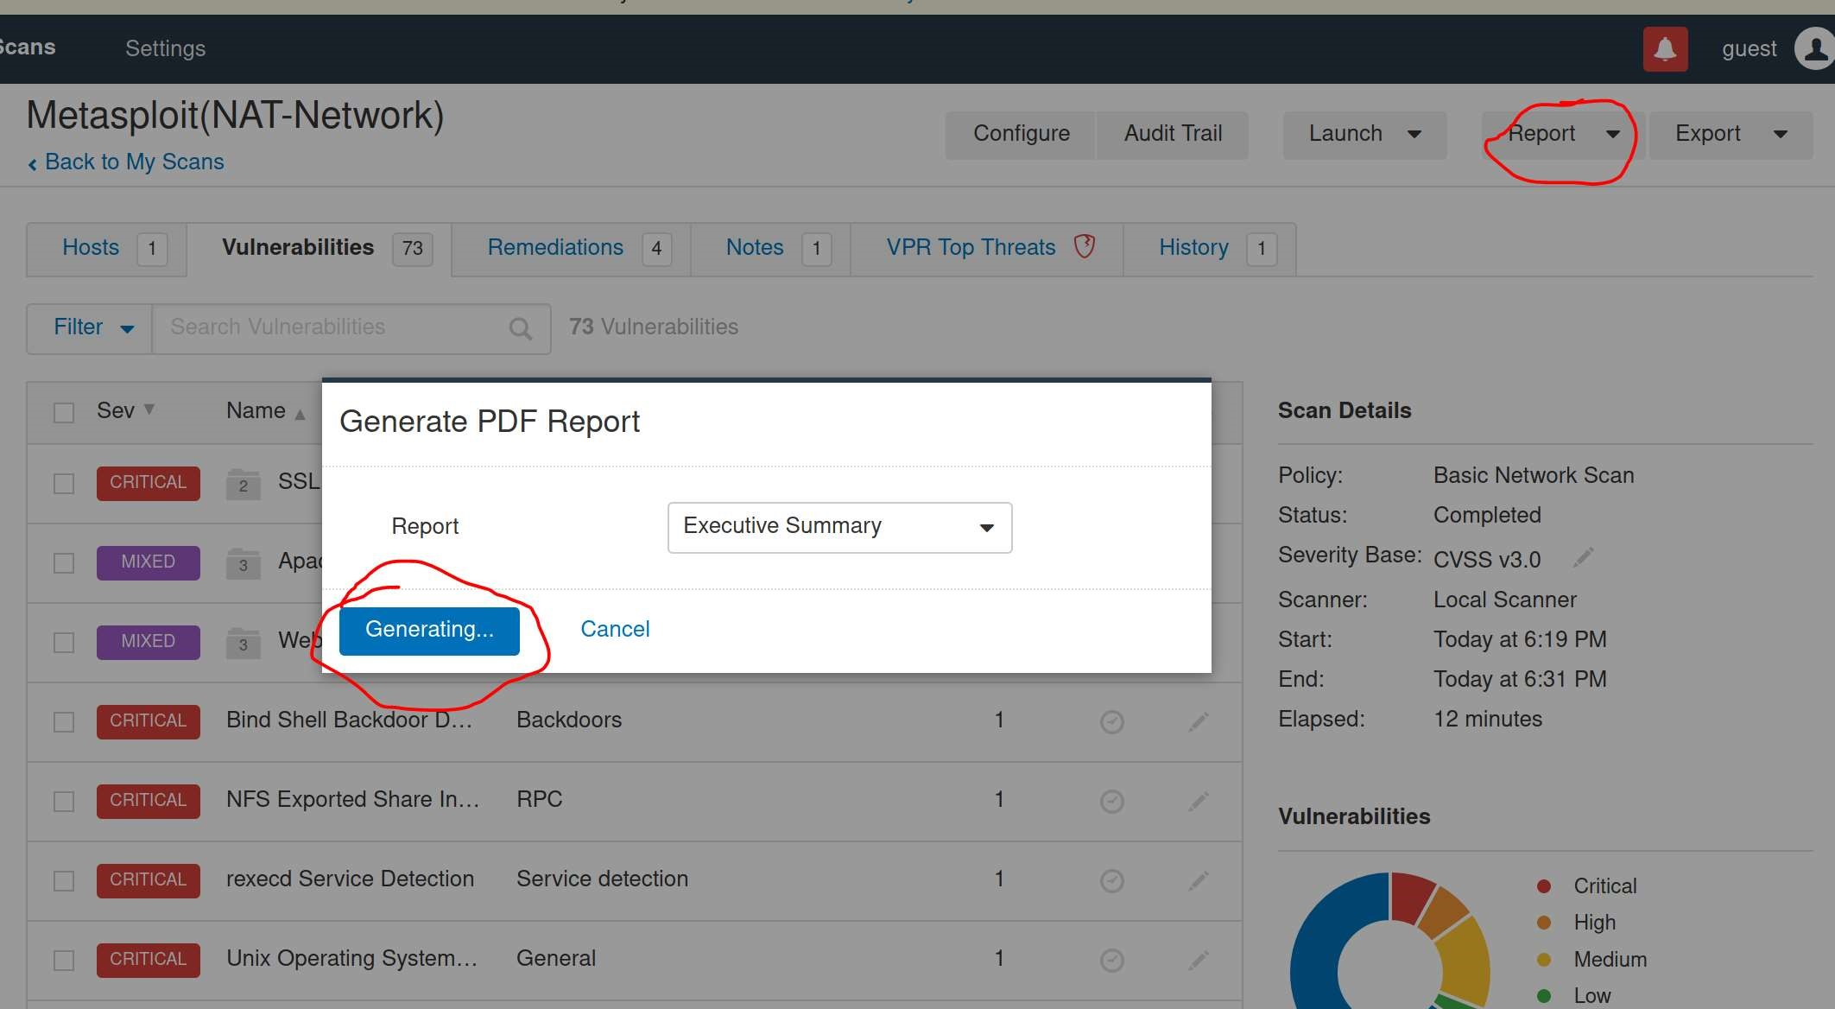

Fig 8.

Nessus Report Results:

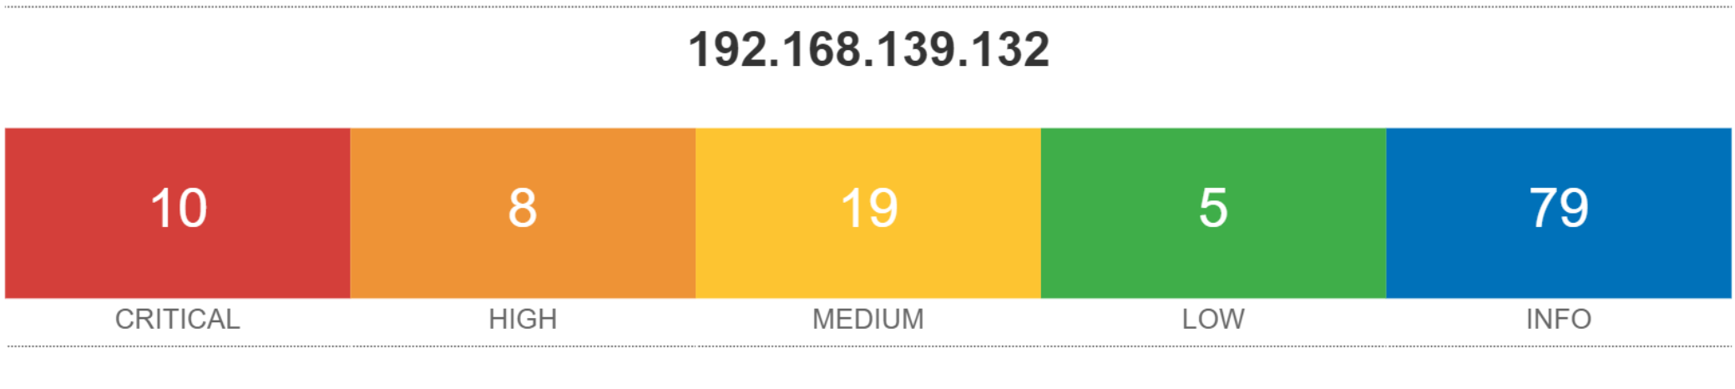

*Full Report on Git-Hub*

**Metasploit: (Daniel)**

Intro: …

Experimental Procedure:

It consists of (X#) steps

Step 1.

…

-Image display of the report at the end

Based on our results, we recommend OpenVAS and Nessus for detecting vulnerabilities in an operating system because both are easy to use and provide details on vulnerabilities detected in a structured manner. These 2 vulnerability assessment systems are best for providing insight into the vulnerabilities we have in our chosen operating systems.

The details Nessus provides on vulnerability systems include how to patch vulnerability and vulnerability numbers that can be identified online for solutions to vulnerability.

What makes OpenVAS stand out in 1 sentence or 2(Devon)

Vulnerability Scaling:

Explain how Nessus scales it’s vulnerabilities

Explain how OpenVAS scales its vulnerabilities

On the other hand, we would recommend Metasploit for …(Exploitation?) because …

Github:<https://github.com/dsgarza/Computer-Systems-Security-Project.git>

Trello:[https://trello.com/b/D8nc0ssm/comp-sys-sec-project#](https://trello.com/b/D8nc0ssm/comp-sys-sec-project)

Project Milestones: (Candan)

Milestone 1

-Proposal

Description:

Our team will brain storm a topic to implement in our project and present our project idea to our professor Gonzalo

Milestone 2

Develop Plan for project

Description:

Our team host a meeting at UIW to discuss what we will need to do for our project and layout a plan on how we should work on project.

Our team came to the conclusion that we would

1st. Identify softwares we would use

2nd. Identify Operating Systems to scan for vulnerabilities

3rd. We need to set up a NAT configuration to create isolated environment

4th. Set up attacker OS and target OS, run software to scan OS, record steps to use software, generate report, and upload our work into our group GitHub repository

5th. Set up tasks for team members on our Trello account to show the progress of the team

Milestone 3

Identify Software and Operating Systems for operation

Description:

Our team came to the conclusion to use Nessus, Openvas, and Metasploit to scan the operating systems Fedora, CentOS, and Metasploitable

Milestone 4

Develop a network for virtual machines

Description:

Our team configured our VMS to a NAT configuration to isolate them from our home networks

Milestone 5

-Execute Software on operating Systems within the network

Install software Nessus, Openvas and, Metasploit

Execute software on Attacker VM to scan for vulnerabilities in target operating systems Fedora, CentOS, and Metasploitable

Milestone 6

-Record, analyze, and then discuss with the team data

Take snap shots of steps used to execute software in word document

Generate vulnerability reports from software and upload to the github repository of the group

Meet with team to discuss which software was most effective and what operating system was most secure

Milestone 7

-Create a Slide presentation

-Submit Report

**Current Status of Project:(Candan)**

* Project is complete and software have been used to scan three operating systems for vulnerabilities

Next Steps:(Candan)

* Present project and submit onto Canvas assignemnets page

Expected Outcomes:(Candan)

* Have a model for a real-world implementation for our topic
* Know when specific sections of project need to be completed by to stay on time

**Deliverables**

**Deliverable 1.**

**Add member tasks in Trello Account-Link in table of contents**

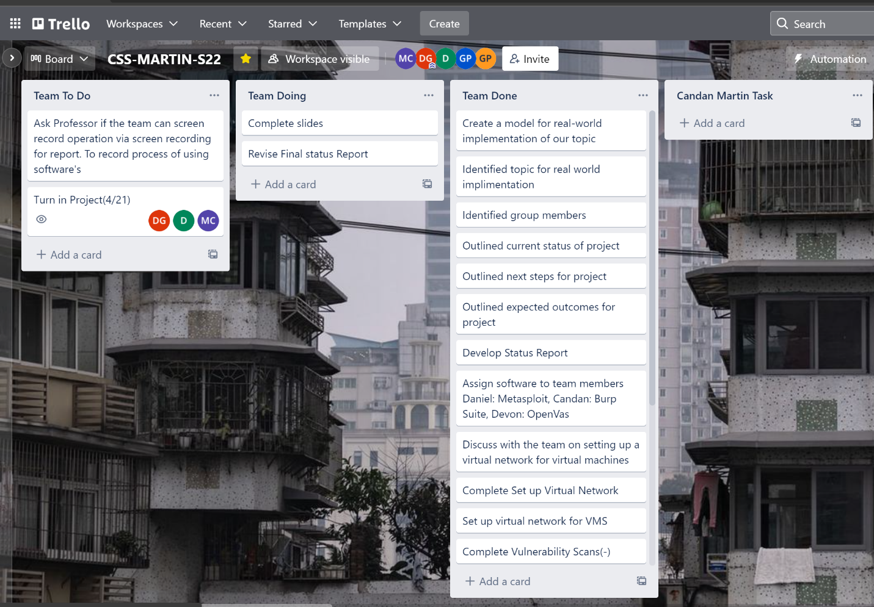

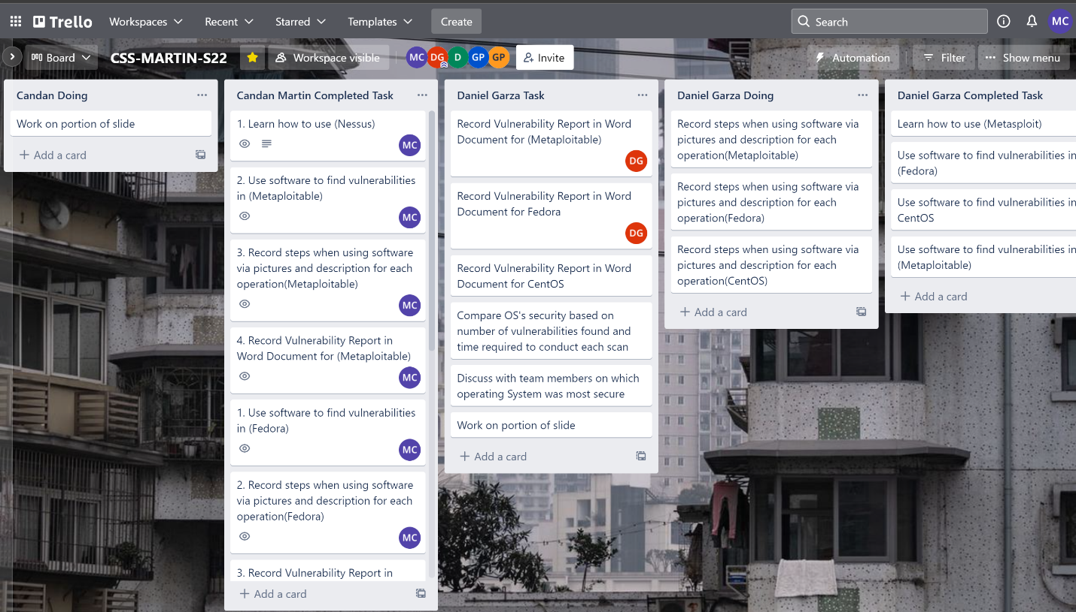

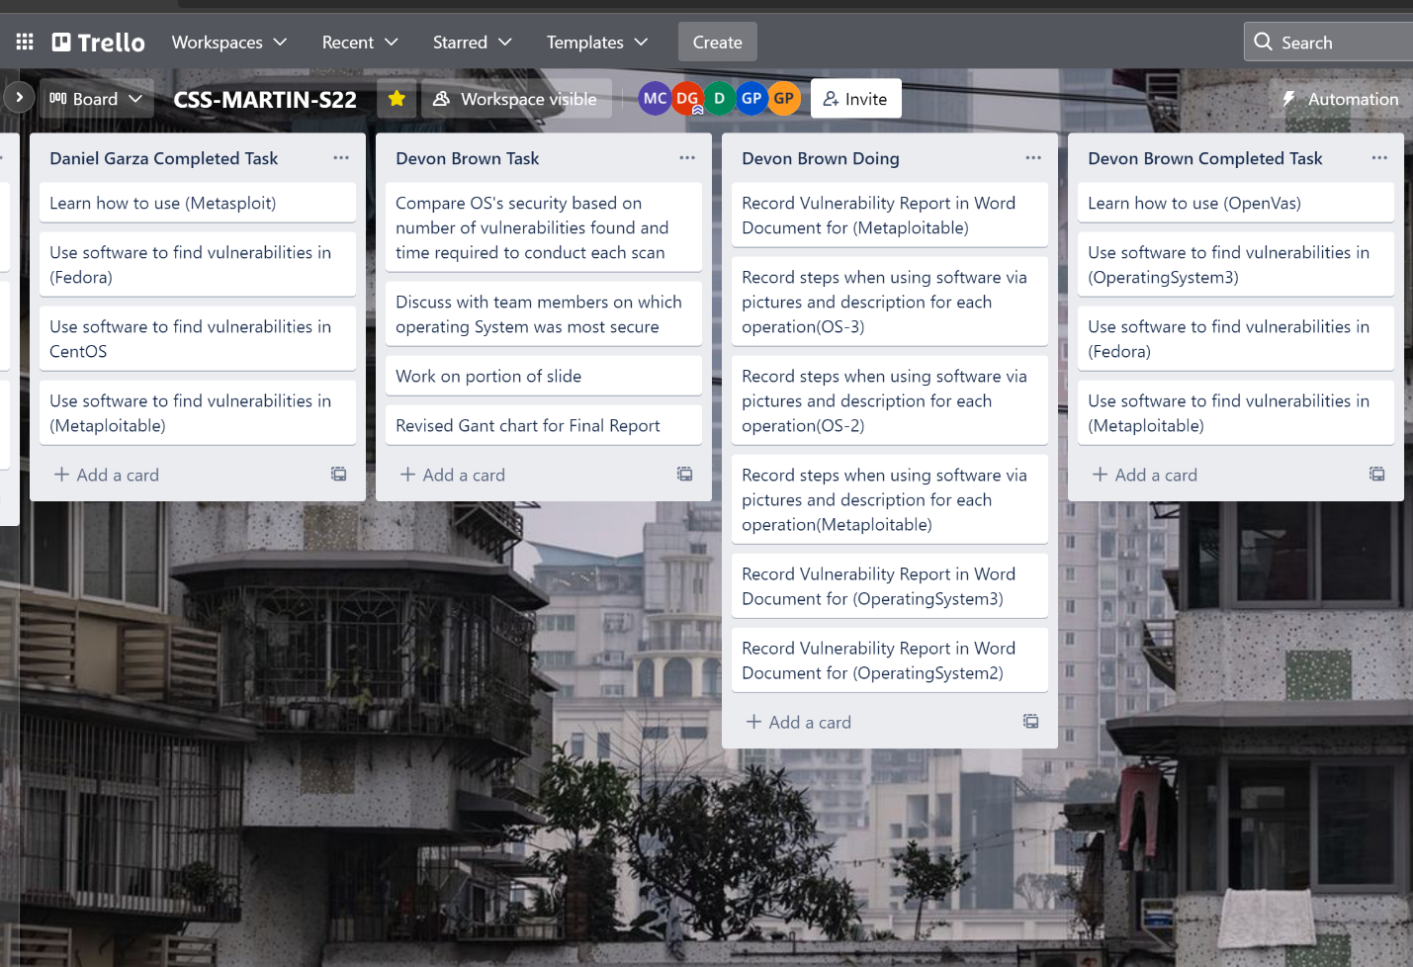

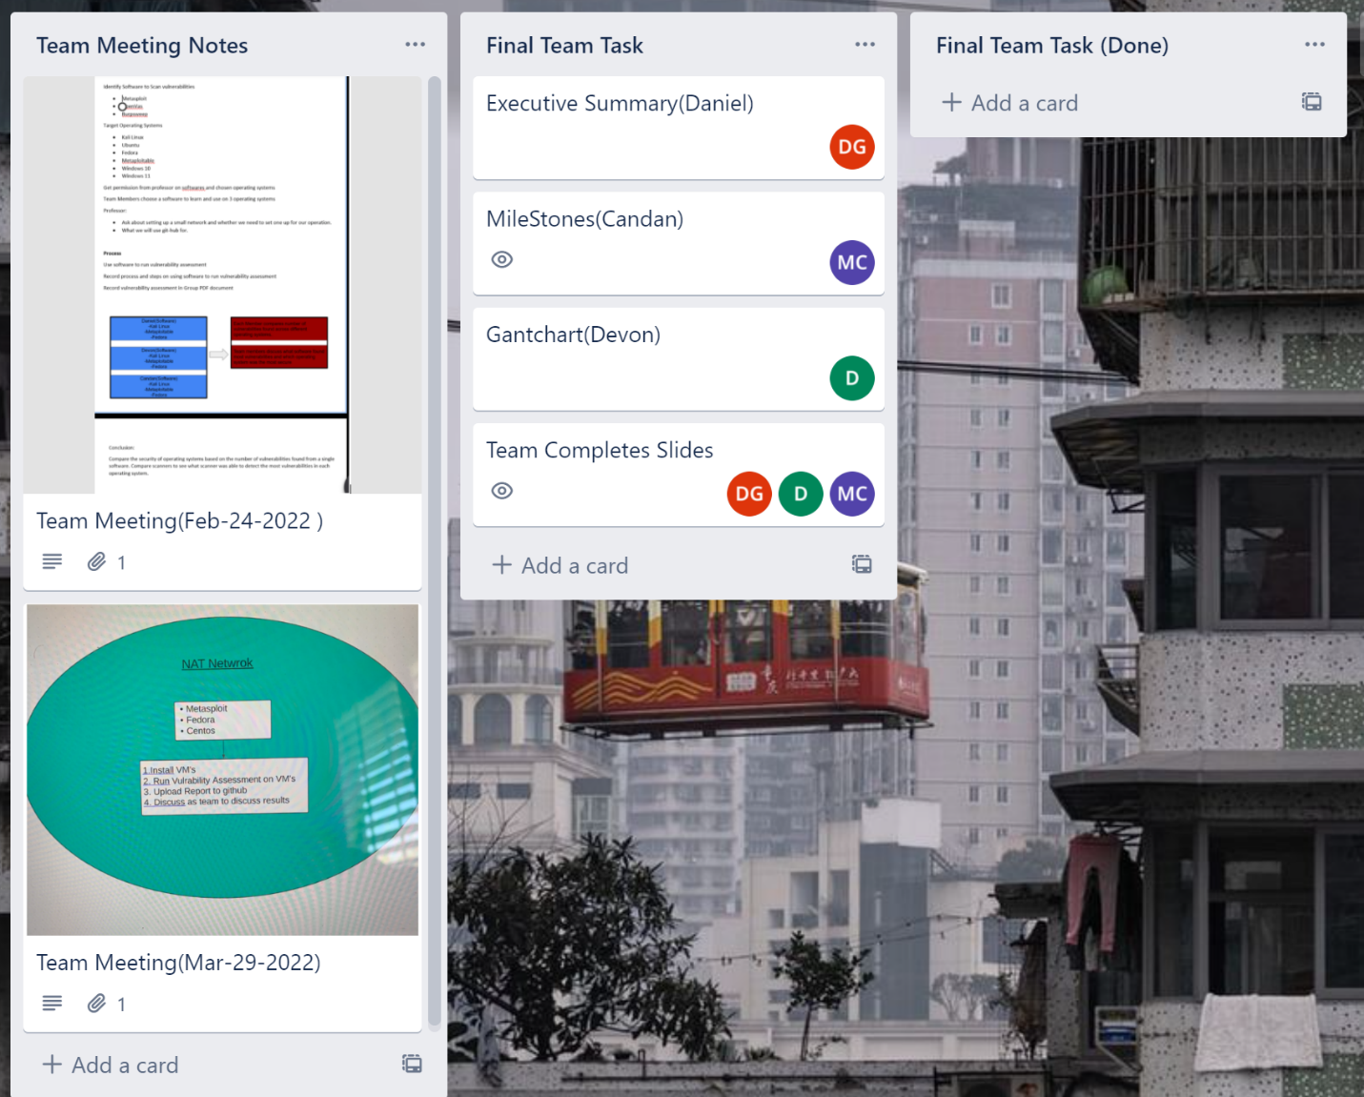

**Deliverable 2.**

**Documents showing how we used software and our generated reports were uploaded to team GitHub-Link in table of contents**

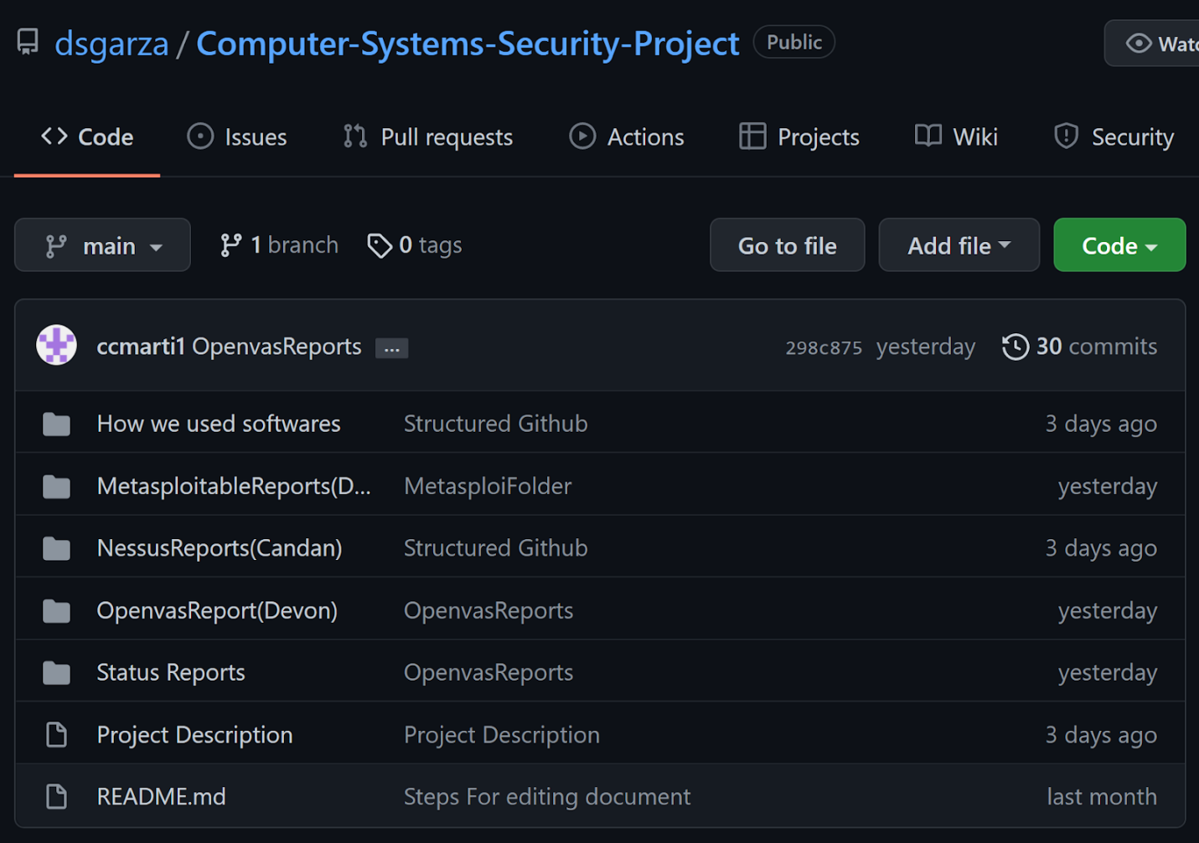

**Deliverable 3.**

**Presentation Slide Made- Link in table of contents**

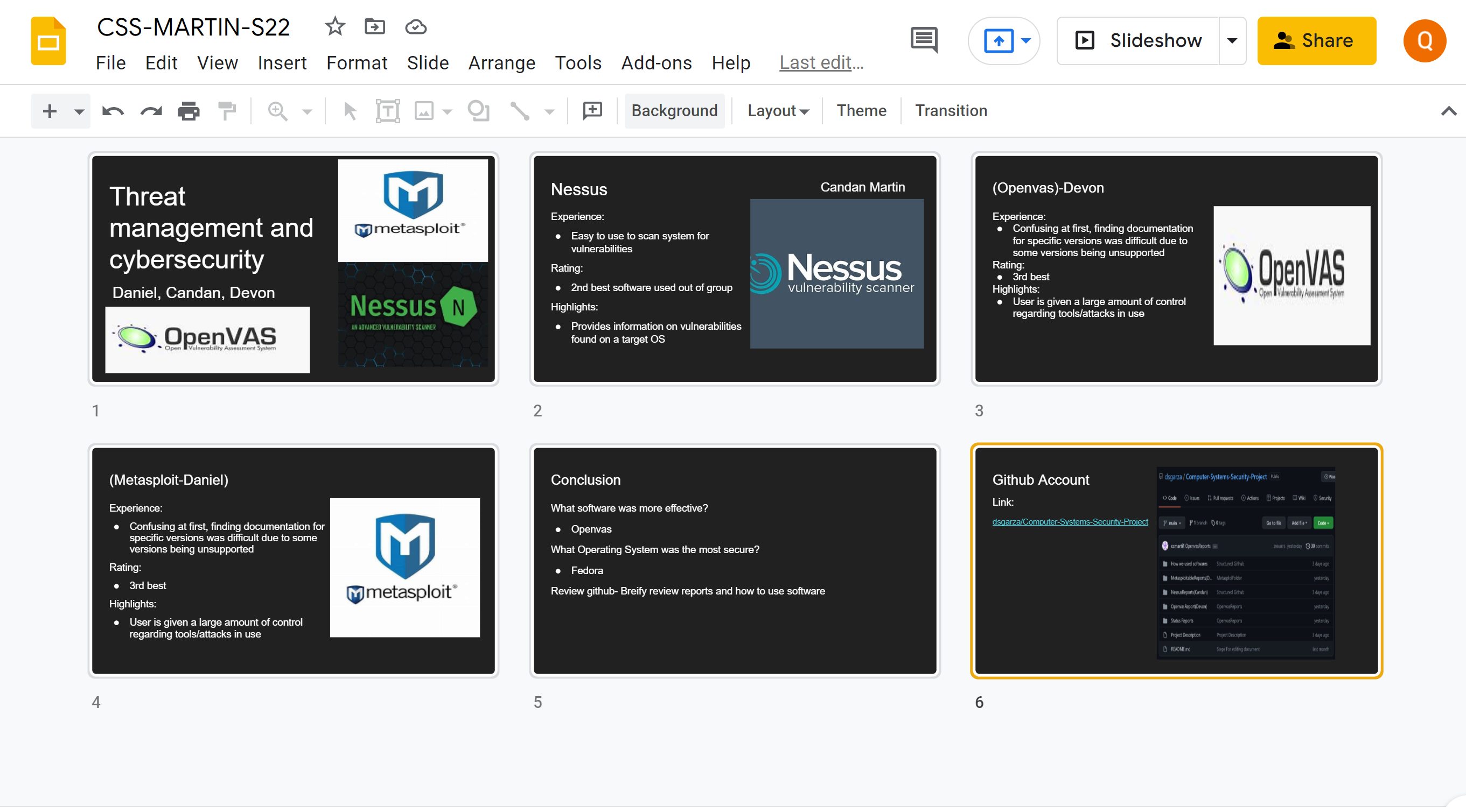

**Deliverable 4.**

**Plan out how we will execute our project**

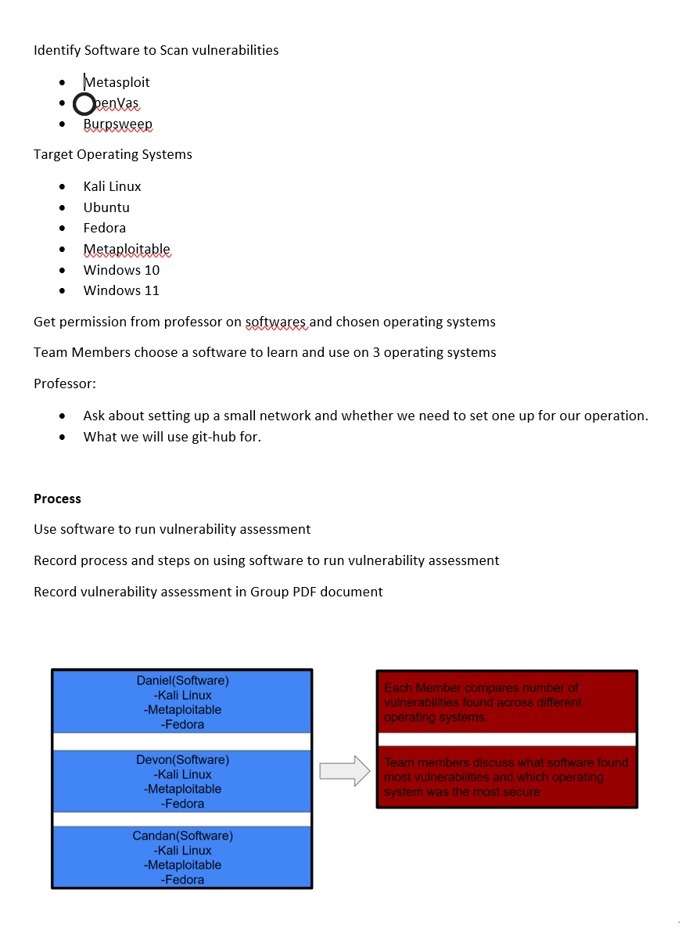

**Professional Accomplishments**

1. **Learn to work in a collaborative environment in a team**
2. **Development of skills on project management and constructing a plan to implement a task given. Our task given was implementing the topic our team chose.**

**Individually**

**Candan-**

1. **Learned how to use Nessus to scan operating systems**
2. **Learned how to structure plans for project implementation and collaborating with team for ideas**
3. **Learned how to configure NAT network**

**Daniel-**

1. **Learned how to use Armitage software**
2. **Learned how to work Unix/Linux operating systems efficiently**
3. **Learned time/project management**

**Devon-**

**Put what you were able to learn during project. Maybe software and gantchart**

**Project Schedule Management**

Gantt chart(Devon)

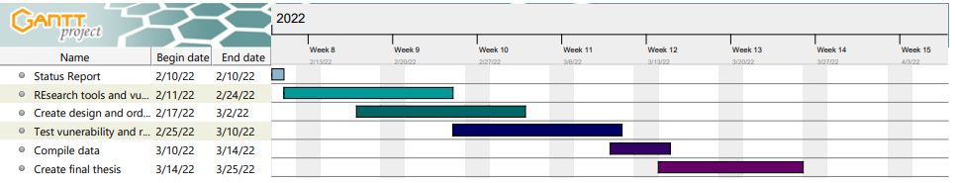

COMMENTS

-Gonzalo Parra just made a new comment on the submission for Candan Martin for Status Report

Excellent, make sure you **build some good case scenarios** and **present their corresponding demos.** Also, make sure you **follow the format I provided** you. Make sure you **update your Gantt chart and Trello** as soon as you start defining the tasks for each milestone.(**Once you start defining task for each milestone**)



